* Create a pod with the name “imperative-nginx” and with the image nginx and latest tag. using Imperative command (not yaml).
  + Kubectl run imperative-nginx –image=nginx
  + Kubectl get pod

1. Create a pod with the name “imperative-nginx” and with the image nginx and latest tag. using Imperative command (not yaml).
2. 

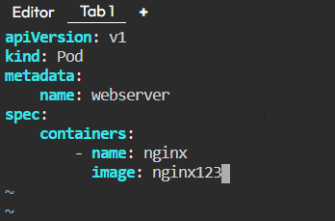

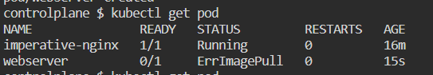

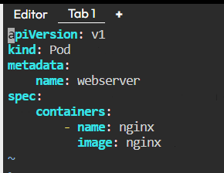



1. 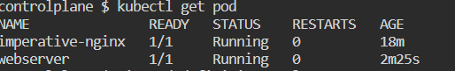
2. 7-delete
3. 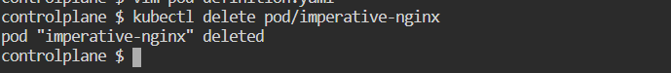

Two commands



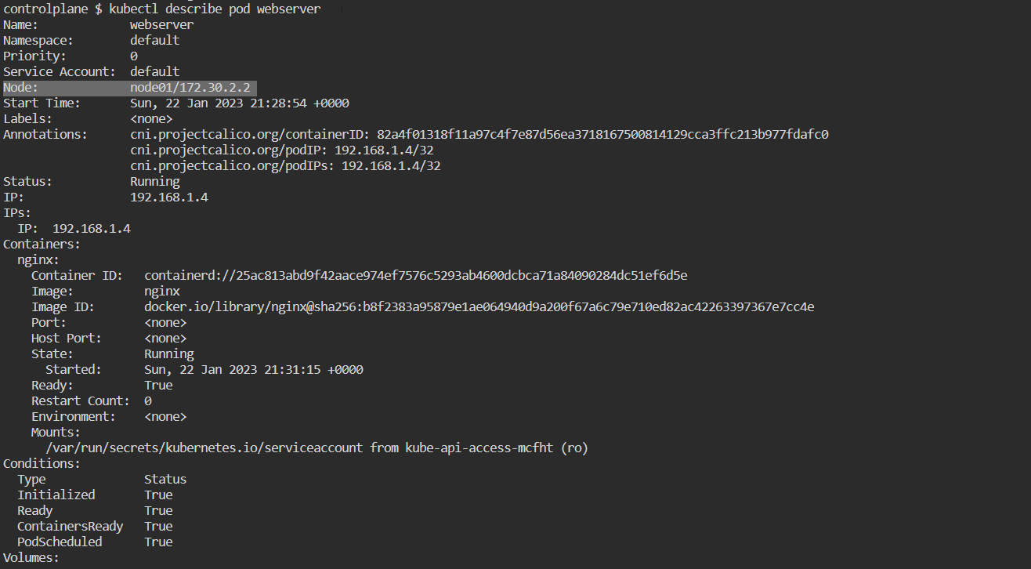

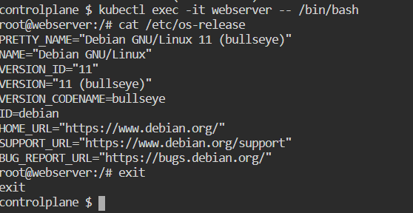

12 - 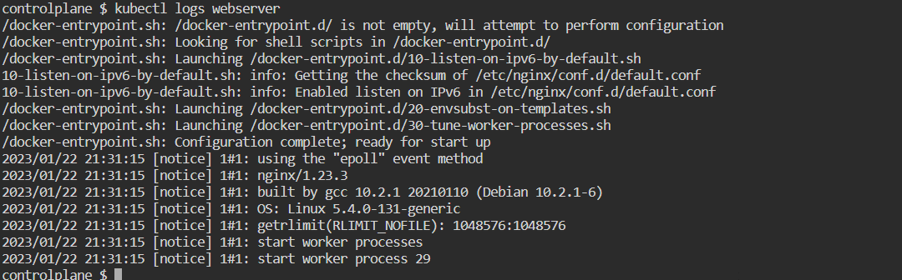

13-

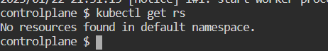

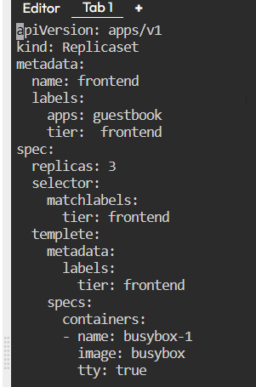

apiVersion: apps/v3

kind: ReplicaSet

metadata:

name: frontend

labels:

apps: guestbook

tier: frontend

spec:

replicas: 3

selector:

matchLabels:

tier: frontend

templete:

metadata:

labels:

tier: frontend

specs:

containers:

- name: busybox-1

image: busybox

tty: true

apiVersion: apps/v1

kind: ReplicaSet

metadata:

name: frontend

labels:

app: guestbook

tier: frontend

spec:

replicas: 3

selector:

matchLabels:

tier: frontend

template:

metadata:

labels:

tier: frontend

spec:

containers:

- name: busybox-1

image: busybox

tty: true

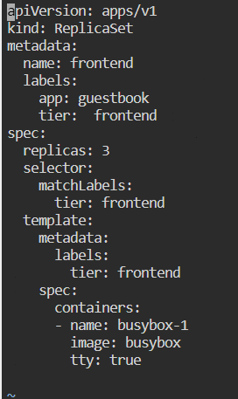

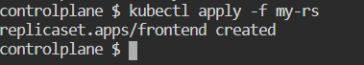

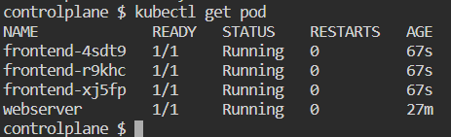

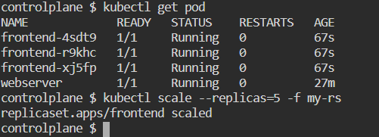

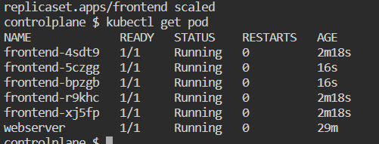

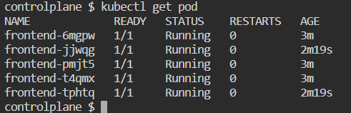

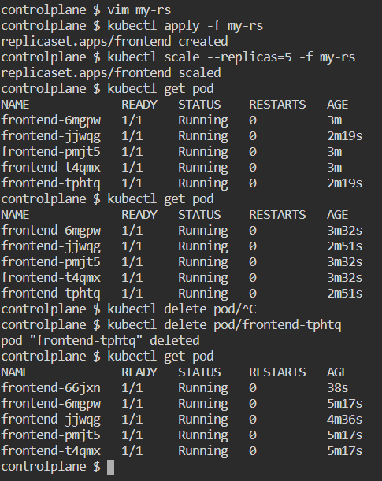

1. 2- Create a pod with the name webserver and with the image “nginx123”Use a pod-definition YAML file. 3- What is the nginx pod status? 4- Change the nginx pod image to “nginx” check the status again 5- How many pods are running in the system? Type the command to show this 6- What does READY column in the output of get pods command indicate? 7- Delete first pod named imperative-nginx you just created. Type the command to do this 8- Which node is pod named webserver running on (list two commands to do this) 9- Get a shell to the running container i.e ssh into it (figure out the command) 10- Run cat /etc/os-release inside the container 11- Exit from the shell (/bin/bash) session 12- Get logs of pod, what are logs and what they are used for? 13- How many ReplicaSets exist on the system? 14- create a ReplicaSet withname= replica-set-1 image= busybox replicas= 3 15- Scale the ReplicaSet replica-set-1 to 5 PODs. 16- How many PODs are READY in the replica-set-1? 17- Delete any one of the 5 PODs then check How many PODs exist now? Why are there still 5 PODs, even after you deleted one?

Write python functions to be phonebook takes some inputs from the user and save the inputs to CSV file renamed with contactbook_insertion date and time automatically, merge from an old contact book, and save the insertion date and time to the file also, search and update function to take any word from the user and search if it exists asks the user to keep it, update it or delete it, and add these options 1- add new entry , 2- update old entry , 3- delete entry , 4- merge from old contact book 5- backup to different local location 6- backup to AWS using boto3 library.

1. First option to ask the user the input will be entered manually or bulk via previously stored contact book

* In case of the user want to migrate an old contact book to the new one ask for the location of the CSV file and then return to the main menu to ask if the user want to add another record.
* In case of the user will enter the input manually show these options
  + username and it must accept letters only not numbers.
  + address.
  + phone number and it must be numbers only and 11 number and start with 01, any ask the user if he may add second or third number.
  + email and it must contain @.

1. Second option search and update
   1. The user will enter word and you will search if the word found ask the user to few options
      1. Delete
      2. Update
      3. Keep it as its
2. Third option is backup
   1. Backup to online storage as AWS using boto3 library
   2. Backup to another local storage and ask the user for the location

Write python functions to takes some inputs from the user and save the inputs to CSV file renamed with contactbook_insertion date and time automatically below the needed options.

1. First to ask the user if the entry will be entered manually or bulk via previously stored contact book
   * In case of the user want to migrate an old contact book to the new one ask for the location of the CSV file and then return to the main menu after migration to ask if the user want to add another record.
   * In case of the user will enter the input manually take the below inputs
     + Record the insertion date and time.
     + username and it must accept letters only not numbers.
     + address.
     + phone number and it must be numbers only and 11 number and start with 01, any ask the user if he may add second or third number.
     + email and it must contain @.
2. Second option view, search and update
   1. View contact
      1. List the contacts in alphabetical order.
      2. List based on creation date.
   2. Search & update: The user will enter any word and you will search if the word found in the contact book ask the user to few options.
      1. Delete
      2. Update
      3. List the entire entry
      4. Keep it as its
3. Third option is backup
   1. Backup to online storage as AWS using boto3 library
   2. Backup to another local storage and ask the user for the location